|  |
| --- |
| 1.What are the differences between SendWindowMessages and SimulateType input methods? |
| Review Later |
| **SendWindowMessages has hotkey support** |
| **SimulateType does not have hotkey support** |
| SendWindowMessages does not work in the background |
| SimulateType does work in the background |
| SendWindowMessages is compatible with 80% of the applications |
| SimulateType is compatible with 100% of the applications |
| SendWindowMessages auto-empties the input field |
| SimulateType does not auto-empty the input field |
| 2.Which state and file in the Robotic Enterprise (RE) Framework is the Config.xlsx file read? |
| Review Later |
| State: Initialization |
| File: InitAllApplications.xaml |
| State: Process Transaction |
| File: Process.xaml |
| State: Get Transaction Data |
| File: GetTransactionData.xaml |
| **State: Initialization** |
| **File: InitAllSettings.xaml** |
| 3.A developer is creating a process to extract all text from multiple native PDF files. Which activity should the developer use to retrieve the text from an entire PDF file? |
| Review Later |
| **Read PDF Text** |
| Read PDF With OCR |
| Get Text |
| Get OCR Text |
| **4.A developer is using UI Explorer and identifies an element. After identification, the Validate button appears as shown in the following graphic:** |
|  |
|  |
| **.What does the image indicate about selector validation?** |
|  |
| Review Later |
| Selector was not available at the time of validation |
| Selector validation resulted in a warning |
| **Selector was modified and can be revalidated** |
| Selector validation resulted in an error |
| **5.A developer obtains an employee ID from a website and stores it in the variable employeeID. Each ID is a 9-character string which starts with the letters AHX, followed by 6 random digits.** |
|  |
| **If the developer needs to extract the digits from the string, which expression can be used?** |
| Review Later |
| employeeID.LastIndexOf("AHX").ToString |
| employeeID.Replace(“”, “AHX”) |
| employeeID.Substring(6, 3) |
| **employeeID.Trim("AHX".ToCharArray)** |
| **6.What is a key advantage of a Robotic Enterprise (RE) Framework Dispatcher process using queues?** |
| Review Later |
| Ensures all data is in a similar format and reads from an Orchestrator queue |
| Each Queue Item is added to the queue by the same robot that will process that Queue Item |
| **Better error handling while extracting data from multiple sources and adding it directly to queues** |
| Ease of use because the REFramework creates the queue by default |
| 7.After finishing development, a developer observes in UAT that a selector corresponding to a UI element within an application changed. This breaks the automation and the automation fails to execute as expected. |
|  |
| Based on UiPath recommendations, what is the correct sequence of steps the developer should take to debug the error and remedy the issue? |
|  |
| **8.Instructions: From the drop-down list, select the correct number in which each step should occur.** |
| Review Later |
| 1234 |
| Update the Selector causing the exception to make it more dynamic and robust 4 |
| 1234 |
| Run in Debug mode to ensure the process runs without the exception 1 |
| 1234 |
| Check the logs for the error location and navigate to the activity with the exception 2 |
| 1234 |
| Validate the Selector and add a breakpoint at the activity 3 |
| 9.A developer wants to combine employee records from two datatables as shown below: |
|  |
|  |
|  |
| Each datatable consists of an employee's name, ID, and location. The datatable is sorted on ID. |
|  |
|  |
|  |
| **Which consecutive activities should be used if the developer wants the output shown in DataTable 3?** |
| Review Later |
| Join Data Table, Sort Data Table, and Remove Data Column |
| Remove Data Column, Join Data Table, and Sort Data Table |
| Merge Data Table, Remove Data Column, and Sort Data Table |
| **Merge Data Table, Sort Data Table, and Remove Data Column** |
| **10.A process uses the Robotic Enterprise (RE) Framework with Orchestrator queues. The value of the Max # of retries on the queue is 3 and the MaxRetryNumber value in the config file is 0.** |
|  |
| **In the event of repeating System Exceptions, what is the maximum number of times a Queue Item will be retried?** |
| Review Later |
| 0 |
| 1 |
| 2 |
| **3** |
| A process, based on Robotic Enterprise (RE) Framework 2021.10, runs on Orchestrator and an error is thrown in the Initialization state in Framework\InitAllSettings.xaml. The project has the default values for the settings in Config.xlsx. |
|  |
| What is state of the job in Orchestrator? |
| Review Later |
| **Faulted** |
| Suspended |
| Successful |
| Stopped |
| 11.You are working with an application that allows all types of input methods for the Type Into activity. Which property should be enabled for the fastest execution? |
| Review Later |
| EmptyField |
| SendWindowMessages |
| ClickBeforeTyping |
| **SimulateType** |
| **12.A developer used the Robotic Enterprise (RE) Framework to create a Performer process. In which workflow(s) is the Queue Item status updated?** |
| Review Later |
| **GetTransactionData.xaml and Process.xaml** |
| GetTransactionData.xaml and SetTransactionStatus.xaml |
| SetTransactionStatus.xaml only |
| Process.xaml and SetTransactionStatus.xaml |
| 13.A developer plans to create a process to automate a web application. In order for the robot to perform an action as soon as the element has appeared, regardless of whether other elements appeared or not, which property value should be configured? |
| Review Later |
| **WaitForReady = None** |
| SimulateType = True |
| WaitForReady = Interactive |
| Timeout (milliseconds) = 0 |
| 14.A developer uses Workflow Analyzer to check the process shown in the following graphic. |
|  |
|  |
|  |
| If the Workflow Analyzer is configured with the default rules, which warning will be shown in the Error List? |
| Review Later |
| Variable Counter does not respect the set pattern ^(dt_)?([A-Z]|[a-z])+([0-9])*$ |
| Flowchart 'Main Flowchart' is used in a secondary layer in Main |
| Activity Assign has a default name |
| **Potential infinite loop detected in Flowchart 'Main Flowchart' starting with Activity Counter < 5** |

14.A developer uses Workflow Analyzer to check the process shown in the following graphic.  
   
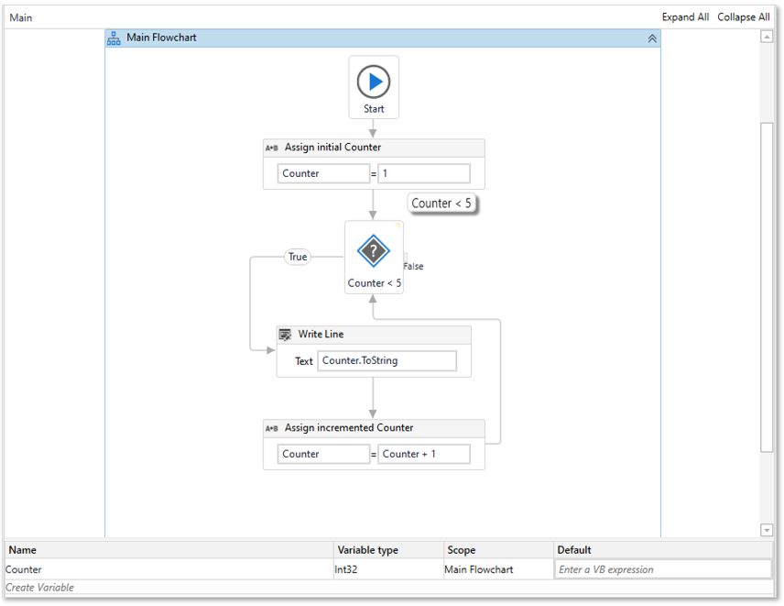  
   
If the Workflow Analyzer is configured with the default rules, which warning will be shown in the Error List?

Review Later

Variable Counter does not respect the set pattern ^(dt_)?([A-Z]|[a-z])+([0-9])*$

Flowchart 'Main Flowchart' is used in a secondary layer in Main

Activity Assign has a default name

**Potential infinite loop detected in Flowchart 'Main Flowchart' starting with Activity Counter < 5**

15.

A developer wants to monitor three buttons using a Trigger Scope activity and three Click Trigger activities. They have added a Switch activity in the Actions section to configure different actions depending on which trigger is activated. The TypeArgument property for the Switch activity is set to **String**.  
  
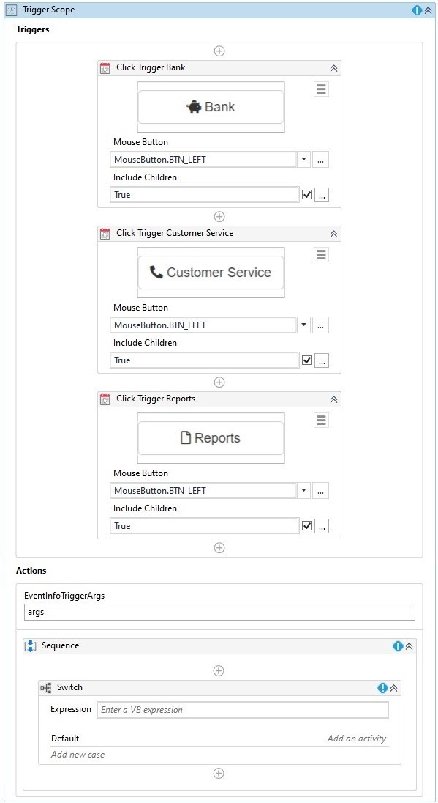  
  
How should the developer configure the Switch Expression property and Case fields?

Review Later

Expression: args.TriggerType.FullName  
Case 1: Bank  
Case 2: Customer Service  
Case 3: Reports

Expression: args.equals()  
Case 1: Click Trigger Bank  
Case 2: Click Trigger Customer Service  
Case 3: Click Trigger Reports

Expression: args.EventInfo  
Case 1: Bank  
Case 2: Customer Service  
Case 3: Reports

**Expression: args.TriggerName  
Case 1: Click Trigger Bank  
Case 2: Click Trigger Customer Service  
Case 3: Click Trigger Reports**

**16**

A developer uses Background Process Automation on a single attended robot. What is a characteristic of the background process?

Review Later

A background process can be transitioned to the foreground with the help of the Use Foreground activity

**A robot can transition interactive UI automation activities from the foreground to the background**

A robot can execute a maximum of two background processes at a time

A robot can run simultaneous background processes that use Click and Type Into activities

**17**

Review the following graphics:  
  
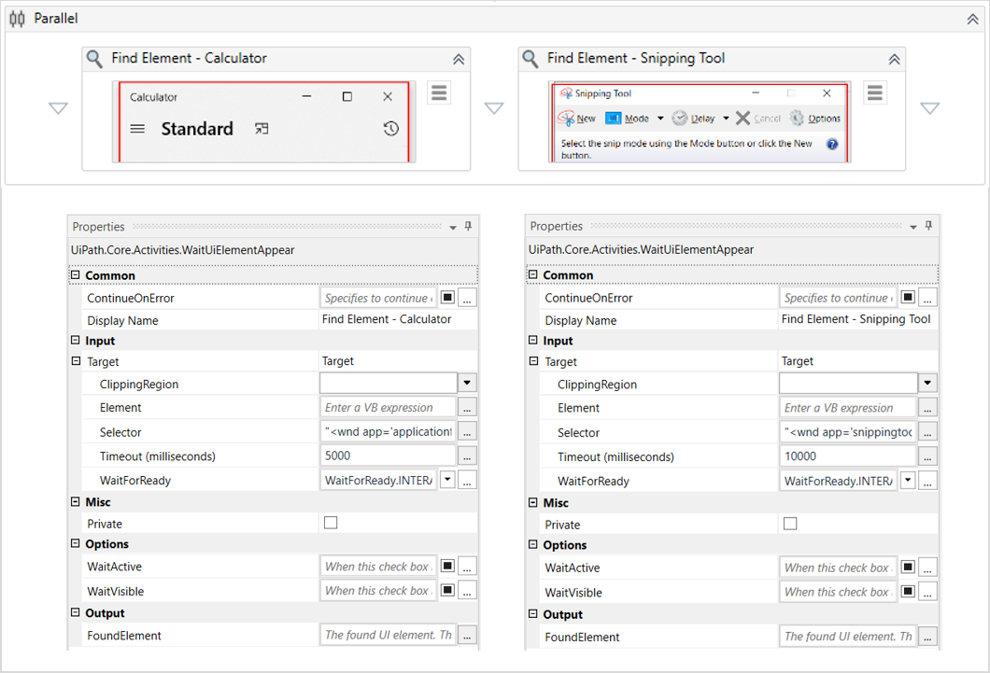  
  
Based on the configuration shown in the graphics, what is the result of the execution of these activities if neither the Calculator nor the SnippingTool are open at runtime?

Review Later

**Workflow throws an exception after 5000 ms - Find Element - Calculator: Activity timeout exceeded**

No exception is thrown and the workflow ends after 10000 ms

Workflow throws an exception after 10000 ms - Find Element - SnippingTool: Activity timeout exceeded

No exception is thrown and the workflow ends after 15000 ms

**18**

A developer is creating an automation that will run on the user machine but should not interfere with the user's work. What should be avoided in this type of process?

Review Later

**Orchestrator Activities**

API Calls

Trigger and Monitor Events

Hardware Events

**19**

A developer decided to create a process using a state machine. What is the correct execution sequence of the parts in the State activity?  
  
**Instructions:** From the drop-down list, select the correct number in which each execution sequence occurs.

Review Later



Activities in the Exit section are performed



Activities in the Destination State are performed



Activities in the Entry section are performed



Activities in the Transition Trigger Action are performed

**20**

What is an advantage of using the default Robotic Enterprise (RE) Framework template with Orchestrator queues?

Review Later

Updates Failed Queue Items with the location of associated screenshots

Reads from multiple queues of varying data at once

Kills all applications open on the machine after a Business Rule Exception

**Always assigns a status of Successful or Abandoned to a Transaction Item**

**21**

A developer is working with a variable named **listCustomerID** of type **List< String >** which is initialized with "1001", "1002" in the same order.

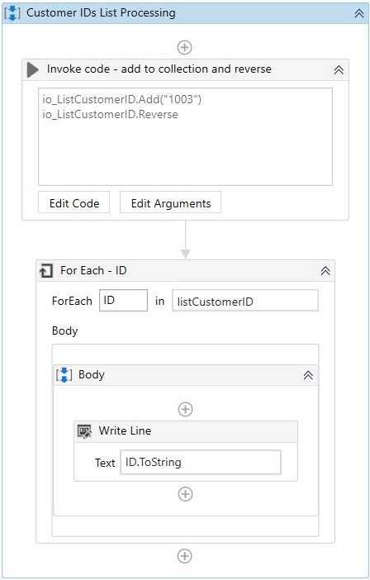

The **Arguments** panel of the Invode Code activity is reflected below:

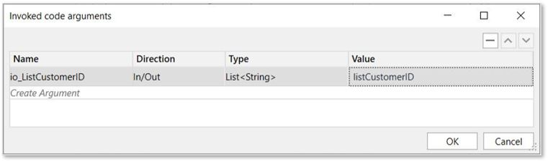  
  
Based on the graphics, what is the output of the Write Line activity?

Review Later

1001  
1002

1001  
1002  
1003

1003

**1003  
1002  
1001**

**22**

Which activity is valid in the Condition of a Retry Scope activity?

Review Later

Check True

File Exists

Find Children

**On Element Appear**

**23**

A developer wants to build a custom solution in their project using the Invoke Code activity. What should be the first step to ensure the necessary namespaces are imported for the invoked code?

Review Later

Import at the end of the code segment

**Import using the Imports panel**

Import using the Package Manager

Import using the Input Arguments property

**24**

Review the following graphics:  
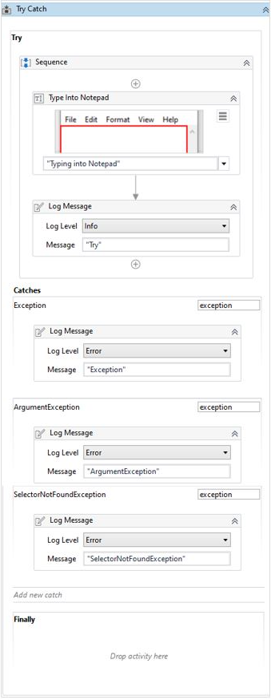  
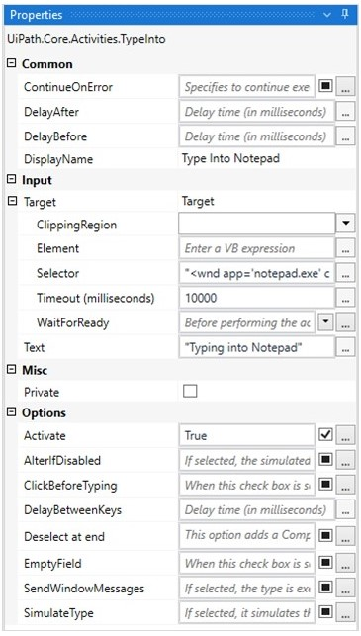  
  
If the automation is executed and Notepad.exe is not running, which Log Message text value is contained in the Output panel?

Review Later

ArgumentException

Try

SelectorNotFoundException

Exception

**25**

A developer designed a process in UiPath Studio that is best-suited for a simple and linear process. Which Studio workflow type was used?

Review Later

Global Exception Handler

Flowchart

**Sequence**

State Machine

**26**

A developer is building a project with an Orchestrator queue. Each object of type QueueItem contains two ItemInformation values.  
  
How can the values of each ItemInformation field be extracted from the variable?

Review Later

Assign output variables for each field in the Add Queue Item activity

Use a Get Transaction Item activity for each ItemInformation field

**Use the SpecificContent property and supply the name of the field as the Key**

Use a Get Asset activity for each ItemInformation field

**27**

You are debugging a workflow created in the Robotic Enterprise (RE) Framework. You set a breakpoint at the "Invoke InitAllSettings workflow" activity. During the debugging process, the Executor is shown as follows:  
  
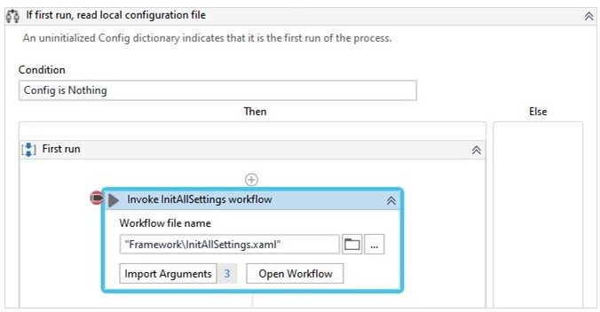  
  
What happens when the **Step Over**button is pressed?

Review Later

**Executor points to the next activity after the "Invoke InitAllSettings workflow" activity**

Executor opens the "InitAllSettings" workflow in a new tab and executes each activity one at a time

Executor pauses at the "Invoke InitAllSettings workflow" activity

Executor points to the first activity inside the "InitAllSettings" workflow

**28**

A developer needs to read data from invoices and then input the extracted data into another system. Each invoice can be processed separately and the order in which they are processed does not matter.  
  
Which type of design is best-suited for this automation?

Review Later

Linear Process

Library

Transactional Process

**Iterative Process**

**29**

A developer created a process that gathers a listing of tickets and their associated details. Using regular expressions, the listing is filtered to retrieve the IDs of all tickets raised for a specific application (APP3). The listing of tickets is retrieved as a String variable and the format of the Ticket IDs is **< ApplicationName > - < TicketNumber >**, where **< ApplicationName >**is**APP3** and the **< TicketNumber >** represents a newly added ticket number.  
  
During testing, the developer notices that the Ticket IDs are correctly identified only if the **< TicketNumber >** has exactly 2-digits.  
  
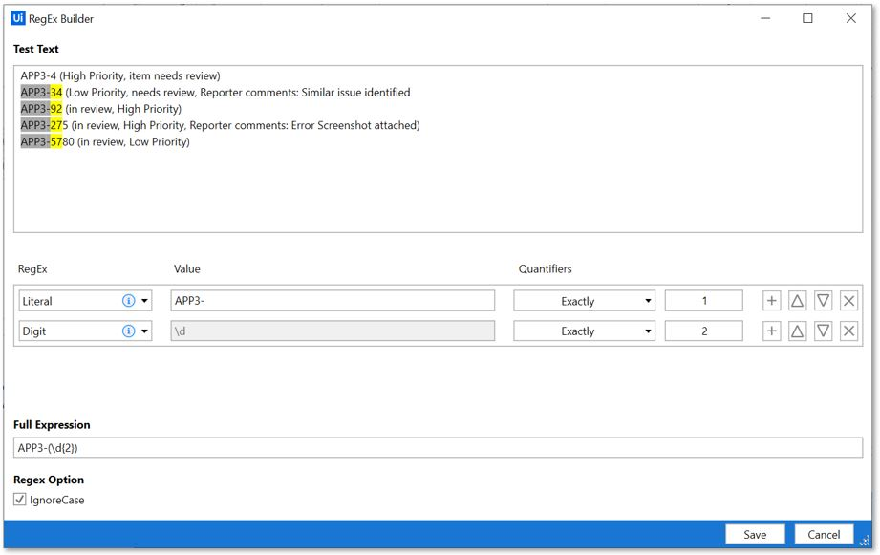  
  
How should the second line of the expression shown in the graphic be modified to ensure that all valid ticket numbers are identified, regardless of how many new tickets are added?

Review Later









**30**

In order to add a row to a datatable named **dt_Reports**, a developer used the Add Data Row activity. However, UiPath Studio throws the exception, **"Add Data Row:Object reference not set to an instance of an object"**, during runtime because the datatable was not initialized.  
  
To correct the error, what should the developer add to an Assign activity before the Add Data Row activity?

Review Later

Assign dt_Reports = New List(Of DataRow)

Assign New System.Data.DataTable = dt_Reports

Assign dt_Reports = New System.Data.DataRow

**Assign dt_Reports = New System.Data.DataTable**

**31**

A developer wants to create an automation that iterates through a dictionary and prints the value of each key. Which activity can iterate through a dictionary?

Review Later

Find Children

Remove from Collection

Select Item

**For Each**

**32**

A developer configured the properties for a Click activity on an element inside a web page as shown in the following graphic.

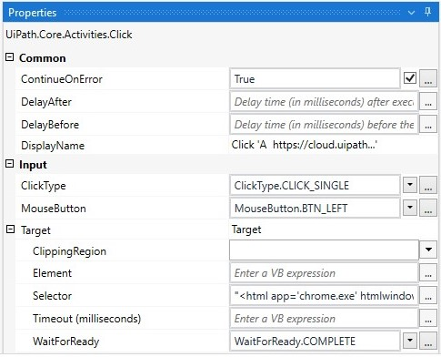

During runtime, the selector is invalid and does not match any element on the web page. What occurs when this Click activity executes?

Review Later

Executes the next activity after the Timeout expires

**Selector not found error occurs after 30 seconds**

Waits 30 seconds before clicking in the center of the web page

Timeout error occurs after 30 seconds

**33**

A developer is automating a process which retrieves technical product details based on user input. The process steps include:  
  
1. Asking the user for a product name  
2. Using the input as a search string in an online catalog  
3. Scraping the structured results list  
  
The developer discovers that the title of the search results page is generated dynamically using the search string.  
   
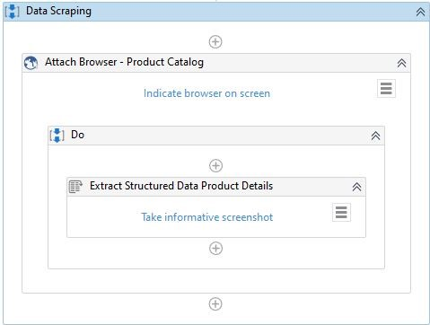  
  
Based on the graphic, what is the recommended way to ensure the robot locates the correct page?

Review Later

**Fine-tune the selector of the Attach Browser activity**

Fine-tune the NextLinkSelector property of the Data Scraping activity

Limit the MaxNumberOfResults property to the number of results displayed on each page and create a loop

Fine-tune the selector of the Data Scraping activity

**34**

A developer creates a new Robotic Enterprise (RE) Framework project in UiPath Studio 2021.10 and changes the value of MaxConsecutiveSystemExceptions to 2 in the Config.xlsx file. How many transaction items can be processed with **Status = Failed and ErrorType = Application** until the process is ended?

Review Later

0

1

2

3

35

A developer has configured the Activity Project Settings for a UI Automation and an Element Exists activity in the project shown below.  
  
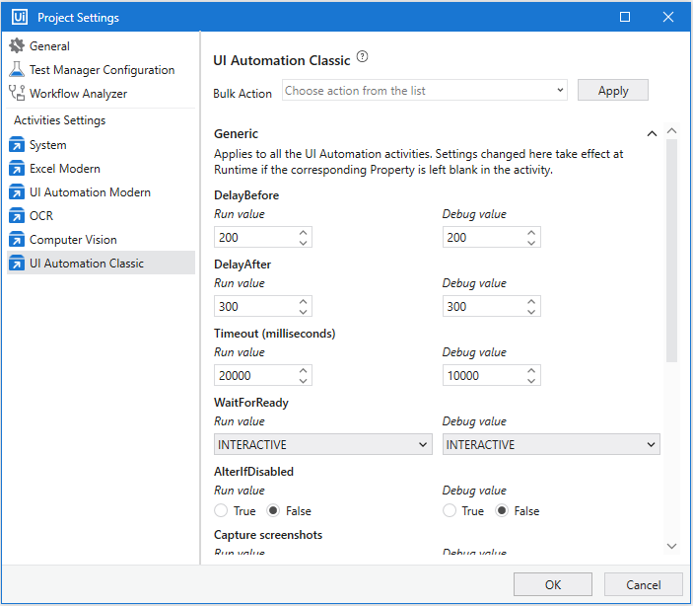  
  
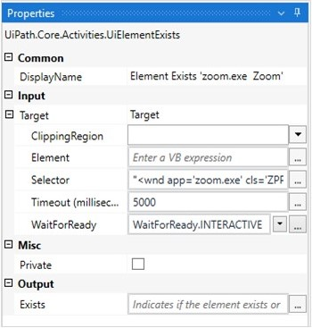  
  
Assuming the element is loaded, how much time will pass before the Element Exists activity is executed in Debug mode?

Review Later

200 milliseconds

300 milliseconds

10000 milliseconds

15000 milliseconds

**36**

A developer needs to debug a process based on the Orchestrator logs. There are no errors or exception messages in the logs. However, the output is not as expected because the Transaction Status of the Queue Items remain in the "In Progress" status. The process execution is finished and the "Execution Ended" log is present in the Orchestrator logs.  
  
What is a possible cause for this behavior?

Review Later

Status automatically changed because a reviewer performed a manual review

Set Transaction Status activity was not used to set the status to "Successful" or "Failed"

Status has been manually changed by an Orchestrator user

Status of the transaction in Orchestrator is not yet updated due to connectivity issues

**37**

A developer automated a process in the Robotic Enterprise (RE) Framework using Orchestrator queues. In which state(s) is the status updated to Successful for each Transaction Item from the queue?

Review Later

Process Transaction only

Initialization and Process Transaction

Get Transaction Data only

Initialization and Get Transaction Data

**38**

A developer wants to automate an invoice process in the Robotic Enterprise (RE) Framework for the Finance team. The subject matter expert (SME) has a requirement to receive an email with the process report at the end of every transaction. In addition, the team requires the email to come from the Director of Finance's email account which may change as employees are promoted.  
  
The developer uses a Send SMTP Mail Message activity at the end of the Process Transaction state and uses the SME email address as the recipient. Based on best practices, where should the Director's email account information be stored?

Review Later

In the Constants sheet in the Config.xlsx file with the value of the email address

In an Orchestrator Credential asset and referenced in the Settings sheet in the Config.xlsx file

**In an Orchestrator Credential asset and referenced in the Assets sheet in the Config.xlsx file**

In an Orchestrator Text asset and referenced in the Assets sheet in the Config.xlsx file

**39**

If you want to read a specific set of pages from a PDF file using the Extract PDF Page Range activity, what describes this activity?

Review Later

Expression "<StartPageNumber> - <EndPageNumber>" is a valid expression for the "Range" field

Password-protected .pdfs cannot be read using this activity

If "Range" = "" is provided, it will read data from all the pages present in the .pdf file

Output of the activity is a String variable containing data from all the pages read

**40**

A developer notices that in a process that uses the Robotic Enterprise (RE) Framework, sometimes the Initialization state fails with an Application Exception. By default, what happens if the Initialization state fails?

Review Later

Execution goes to the End Process state without any retries on the System Exception transition

Initialization state is retried a number of times equal to the "Max # of retries" defined in the queue

Execution goes to the End Process state after one retry on the System Exception transition

**Initialization state is retried a number of times equal to the MaxRetryNumber defined in the Config.xlsx file**

**41**

A developer created a process to capture caller data from a Call Center application. The process is designed to help a Call Center employee enter details about a call into an Excel sheet. For instance, when an incoming call is received, the employee starts the attended robot. The robot contains four sub-processes:  
  
1. Search for the caller by Caller ID using an HTTP request and retrieve data such as name, address, email, support history  
2. Save the retrieved caller information in an Excel sheet  
3. In a web application, create a new history entry for the caller, upload the Excel sheet, and then submit the form  
4. Send a Microsoft Outlook email with the confirmation  
  
Which sub-process requires modifications to some of the properties' default values of activities to ensure it runs in the background?

Review Later

**1**

2

3

4

**42**

A developer wants to modify the Robotic Enterprise (RE) Framework to make a linear process. Based on the REFramework documentation, which action should the developer perform?

Review Later

**In the GetTransactionData workflow, assign out_TransactionItem = Nothing**

Set the MaxRetryNumber to 0 in the Config.xlsx file

In the GetTransactionData workflow, only assign a value to out_TransactionItem if in_TransactionNumber = 1

Set the MaxRetryNumber to 1 in the Config.xlsx file

**43**

Review the following graphic:  
  
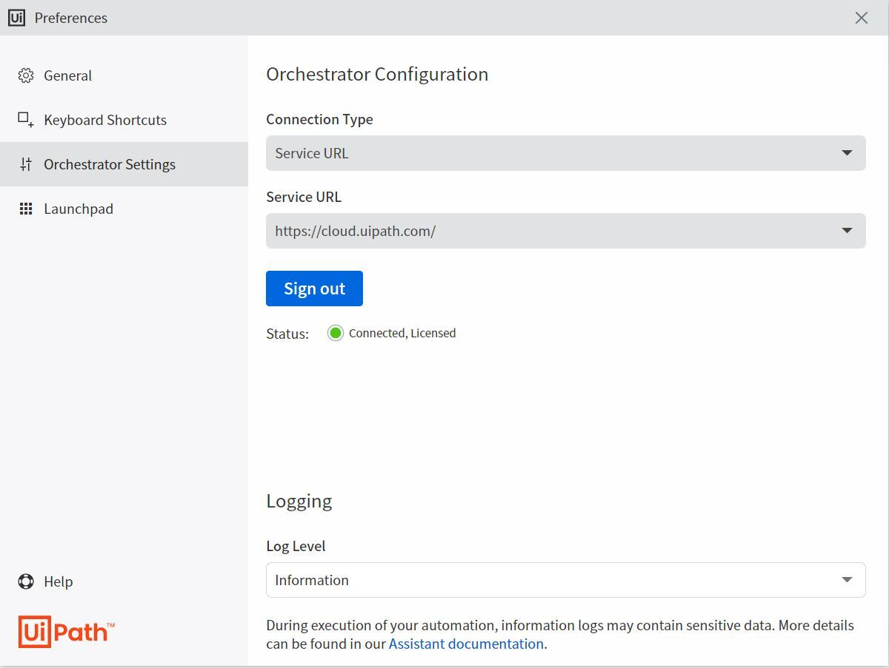  
  
Based on the graphic, logs of which level will be sent to Orchestrator during process execution?

Review Later

Information and above

Trace and above

**Information only**

Verbose, Information and above

**44**

A Click activity with a partial selector is nested inside another activity. In which activity is the Click activity contained for the workflow to execute?

Review Later

Find Element

Excel Application Scope

**Attach Window**

Pick Branch

**45**

You read data from an Excel file into a datatable called **dtEmployee**. The Excel data is shown in the following graphic:  
  
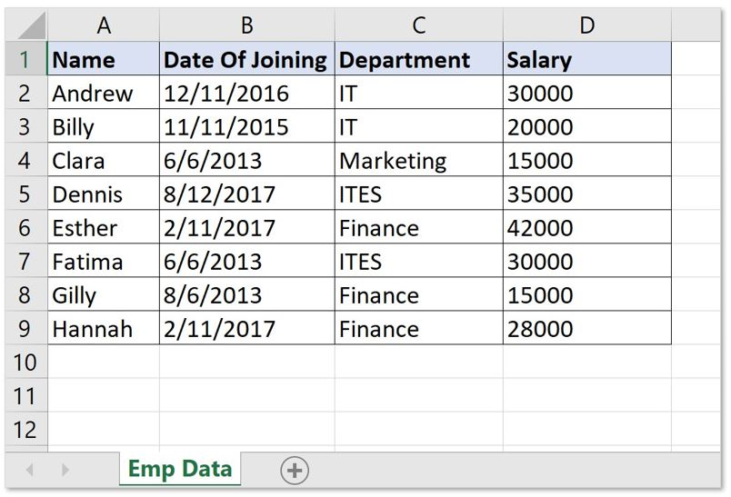  
  
You are required to filter the datatable to get all rows with employees from the Finance and IT departments whose **Salary** is less than 30000. Which expression provides the required results?

Review Later

dtEmployee.Select("[Department]='IT' OR [Department]='Finance' OR [Salary] < 30000")

**dtEmployee.Select("([Department]='IT' OR [Department]='Finance') AND [Salary] < 30000")**

dtEmployee.Select("[Department]='IT' OR [Department]='Finance' AND [Salary] < 30000")

dtEmployee.Select("([Department]='IT' AND [Department]='Finance') AND [Salary] < 30000")

**46**

A developer is working on a project with other developers and using GIT source control in UiPath Studio. The developer made some modifications in the workflow on the local machine and then selected the **Commit and Push** button.  
  
What is the outcome of this action?

Review Later

Current version was committed to the remote repository and pushed to the local repository

**Local changes were committed to the local repository and then pushed to the remote repository**

Current changes were committed and pushed to the local repository

Local changes were committed to the remote repository and then pushed to the remote repository

**47**

You are developing an automation project using the GIT repository. You want to view the differences between two similar workflows in the same project.  
  
What provides this functionality?

Review Later

Compare with Latest

Compare with Previous

**Compare with Selected**

Compare with Local

**48**

A developer created the following sequence:  
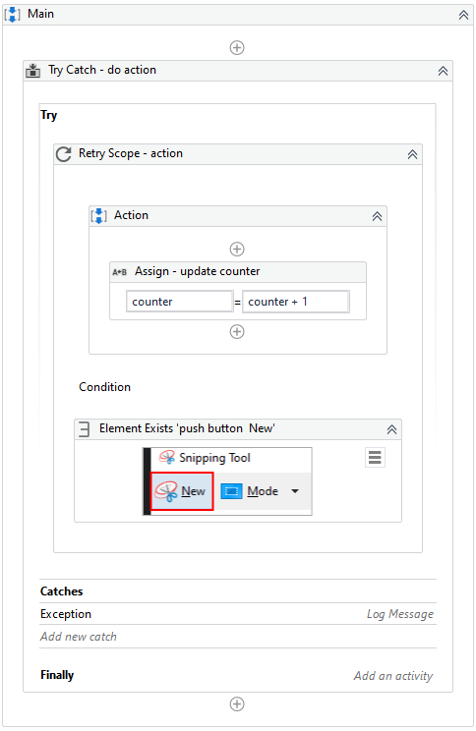  
  
The Catches block within the Try Catch activity contains the following activities:  
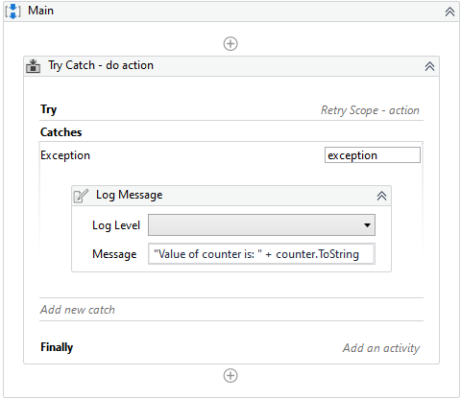  
  
The Properties for the Try Catch activity are shown below:  
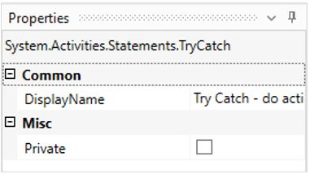  
  
The following reflects the Properties for the Retry Scope activity:  
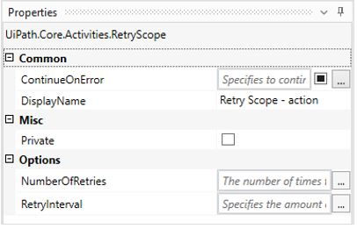  
  
The Properties for the Element Exists activity are shown as follows:  
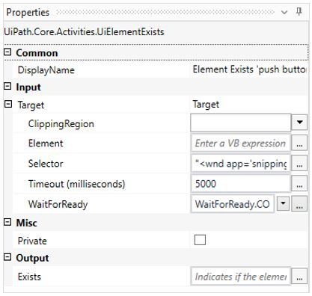  
  
The Variables panel appears below:  
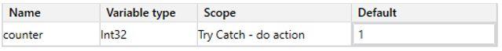  
  
Based on the exhibits, what is the value of the Counter variable when the target application is not open?

Review Later

1

**2**

3

4

**49**

When an unexpected error occurs at the application level in the Process.xaml file of the Robotic Enterprise (RE) Framework, which type of exception is caught by default?

Review Later

**System.ApplicationException**

System.Exception

System.NullReferenceException

UiPath.Core.BusinessRuleException

**50**

Five Queue Items were added to a queue on 12/25/2021. Depending on the Queue Item properties, what is the correct sequence in which these Queue Items will be processed?  
  
**Instructions:** From the drop-down list, select the correct number in which the Queue Items are processed.

Review Later



No deadline  
Priority = High



Deadline = 12/25/2021  
Priority = Low



Deadline = 12/26/2021  
Priority = High



Deadline = 12/26/2021  
Priority = Normal



Deadline = 12/27/2021  
Priority = High

**51**

A developer is modifying a workflow which contains several Invoke Method activities. What is an attribute of the Invoke Method activity?

Review Later

Executes on either a Target Type or Target Object

**Executes multiple VB.NET statements**

Executes a .xaml file with Input arguments

Executes synchronously on a specified workflow

**52**

The output variable of an Extract Structured Data activity contains company names and stock symbols. Which activity will return the company name for a specific input stock symbol?

Review Later

Get Row Item

Lookup Data Table

LookUp Range

**Select Item**

**53**

You need to download a report from the ACME website as shown in the following graphic.  
  
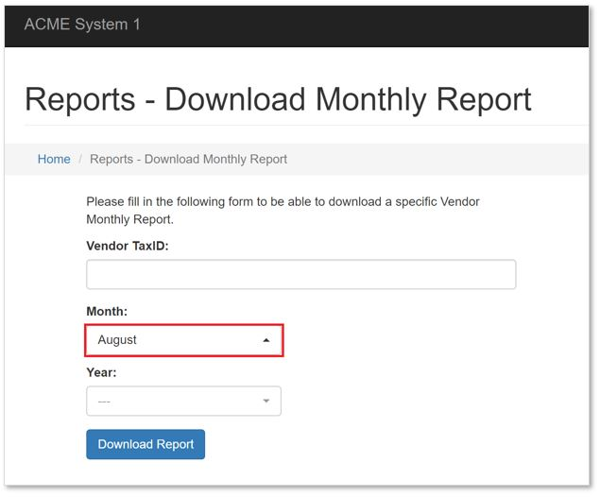  
  
When you capture the **"Month"** field selector, it appears as shown in the following graphic:  
  
  
How should the selector be modified so that it can be used to select the drop-down for any given month?

Review Later

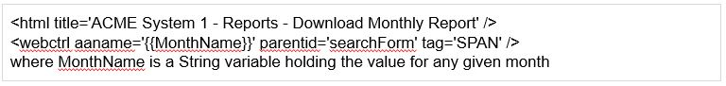

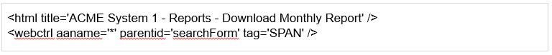

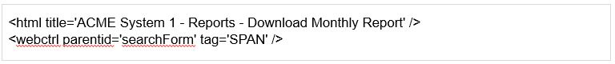

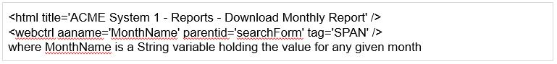

**54**

A developer has followed UiPath best practices when automating a process by using the Robotic Enterprise (RE) Framework. A large number of Orchestrator assets of type Integer are required for the process.  
  
Where in the Config.xlsx file should the names of the Integer assets be referenced?

Review Later

A new sheet

Constants sheet

Assets sheet

**Settings sheet**

**55**

A developer is building a process that needs to click an element which requires a mouse hover to become visible. However, the element does not appear with the default click setting. The input method for the Click activity is Hardware Events.  
  
Which property should the developer configure to be able to click the element?

Review Later

AlterIfDisabled = True

**CursorMotionType = Instant**

CursorMotionType = Smooth

AlterIfDisabled = False

**56**

A developer scrapes data from a website and stores it in three variables: **FirstName**, **LastName**, and **City**. When passing the data to another workflow to be used later in the process, the developer wants to store the three String variables in a fixed-sized data structure named **UserData**.  
  
Based on best practices, which data structure and assignment should the developer use?

Review Later

**UserData is of type List<String>  
UserData = New List(Of String) ({ FirstName, LastName, City })**

UserData is of type String[]  
UserData = {FirstName, LastName, City}

UserData is of type Object[]  
UserData = {FirstName, LastName, City}

UserData is of type List<Object>  
UserData = New List(Of Object) ({ FirstName, LastName, City })

**57**

A developer creates a workflow using PDF Automation in order to extract some fields in an invoice. The selector shown in the following graphic is used for extracting the Invoice Number:  
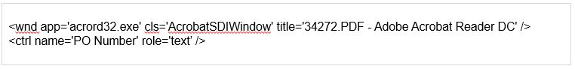  
  
The developer needs to fine-tune the selector in order to use it for more fields in the same invoice. What represents an example of a good selector?

Review Later

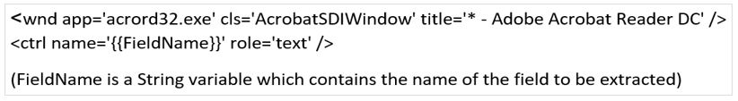





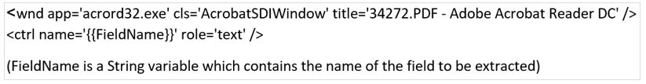

**58**

A developer runs Workflow Analyzer with the default rules and receives the following warning description on one of the workflows:  
  
**Log Message display name is defined many times. Current allowed threshold is 1. Code contains 2.**  
  
What is the cause of the warning?

Review Later

Workflow contains two Log Message activities with the default name

Workflow contains two renamed Log Message activities

Workflow contains two Log Message activities which is not allowed

Workflow contains more than two Log Message activities

Comments

**59**

What is a characteristic of the Final State in a State Machine?

Review Later

A State must be connected to a Final State

A Final State contains the Transitions and the Exit sections

A Final State can only transition to another Final State activity

Must have at least one Transition configured from the Final State

**60**

A developer created a Retry Scope activity as shown in the following graphic:  
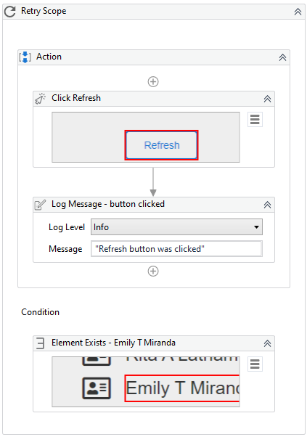  
  
The web page automated in the sequence is shown below:  
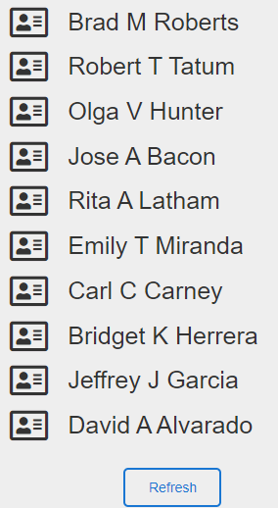  
  
The element defined in the Element Exists activity already exists when the sequence is run. Clicking the Refresh button will not update the web page. What is the content of the Output panel?

Review Later

Retry Scope: Action failed to execute as expected.

Refresh button was clicked  
Retry Scope: Action failed to execute as expected.

Refresh button was clicked

Refresh button was clicked  
Refresh button was clicked

**61**

During the testing phase of developing a process, there was a timeout error. The development team wants to debug the process. They need to know which activities started and ended before the timeout occurred.  
  
To ensure the logs provide this descriptive information in Orchestrator, which logging level must be set?

Review Later

**Information**

Verbose

Trace

Critical

Comments